 | Girl’s Brown Beret
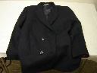 | Boy’s blazer, navy blue
 | Box of Money, Navy Cut Tin
 | Camera Baby Brownie, Black
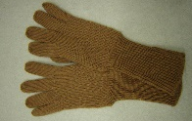 | Pair of child’s hand-knitted gloves
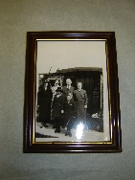 | Black and white photo, framed
 | Brown Suitcase
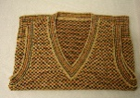 | Child’s woollen tank-top
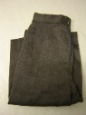 | Boy’s trousers, grey
 | Froggy’s Little Brother, book
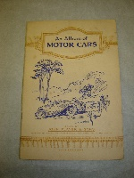 | Album of Motor Cars, Book  Document 1
Mr Midshipman Easy, book Gulliver
Document 2
Sinbad the Sailor, book Gulliver
Document 3
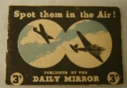 | Spot then in the air book  Document 4
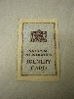 | National Registration Identity Card  Document 5
Evacuee label
Document 6
How to look after your respirator
Leaflet Document 7
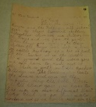 | Letter describing Air Raid  Document 8
Ration Book
Document 9

 | Set of WW2 fact cards

