 | Book Victorian house explained
 | Women’s Black Victorian Boots
 | Scrubbing Brush
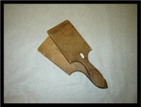 | Butter Pats
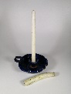 | Candle Holder and 2 Candles (slight exterior damage)
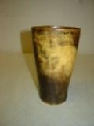 | Horn Cup
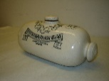 | Doulton’s Ceramic Foot Warmer (chipped)
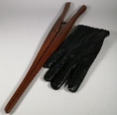 | Glove Stretcher and glove
 | Hair Tongs (2)
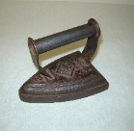 | Large, flat metal Iron
 | Small, flat metal Iron
 | Mustard Jar (slightly chipped)
 | Metal Plate
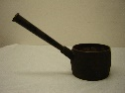 | Metal Saucepan
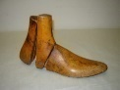 | 3-piece shoe last (looks like a shoe)
 | Soap
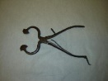 | Sugar Cutters
 | Set of Victorian fact cards

